**AGILE**

Agile SDLC model is a combination of iterative and incremental process models with focus on process adaptability and customer satisfaction by rapid delivery of working software product. Agile Methods break the product into small incremental builds.

Or

The Agile methodology is a project management approach that involves breaking the project into phases and emphasizes continuous collaboration and improvement.

Agile cycle invlolves

* Plan
* Design
* Coding
* Testing
* Release
* Feedback

**Roles of Agile**

1. **ScrumMaster**

Master is responsible for setting up the team, sprint meeting and removes obstacles to progress

1. **Product Owner**

The Product Owner creates product backlog, prioritizes the backlog and is responsible for the delivery of the functionality at each iteration

1. **ScrumTeam**

Team manages its own work and organizes the work to complete the sprint or cycle

**Agile Methodologies**

1. Scrum
2. Crystal Methodologies
3. DSDM
4. FDD
5. Lean Software Development
6. XP
7. **SCRUM**

Scrum is one of the many types of agile methodology, known for breaking projects down into sizable chunks called “sprints.” Agile scrum methodology is good for businesses that need to finish specific projects quickly.

Agile scrum methodology is a project management system that relies on incremental development. Each iteration consists of 2 to 4 week sprints, where each sprint aims to build the most important features first and come out with a potentially deliverable product.

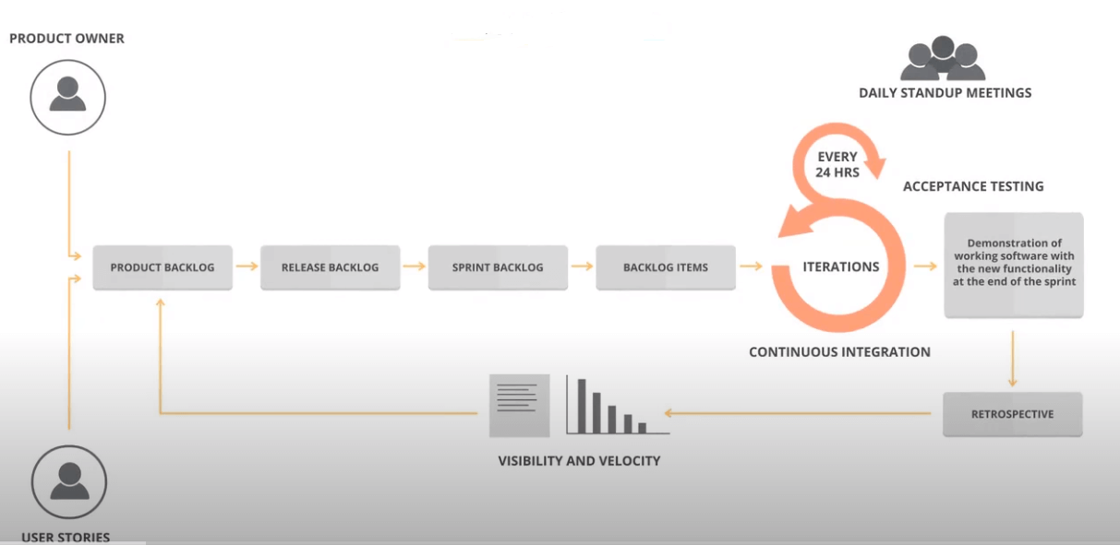**Scrum Process Flow**

1. **CRYSTAL METHODOLOGY**

Crystal method is an agile software development approach that *focuses primarily on people and their interactions when working on a project rather than on processes and tools.*

The crystal method is an agile framework that is considered a lightweight or agile methodology that focuses on individuals and their interactions.

techniques consists of 3 stages - **chartering, cyclic delivery and wrap up**.

**Chartering** involves creation of development team, conducting preliminary feasibility analysis, developing initial plan and fine tune development process.

**Cyclic delivery** consists of few delivery cycles during which a team updates and refines release plan, implements a set of requirements through more than one integrated iterations, delivery of integrated product to end users and finally review the plan of the project and adopted development methodology.

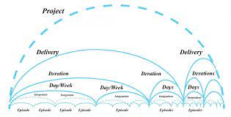

1. **DYNAMIC SOFTWARE DEVELOPMENT METHOD**

It is a Rapid Application Development approach to software development that offers an agile project delivery framework. The participants of the team are expected to involve actively in the development activities with necessary decision-making powers vested in them.

A DSDM project involves 7 phases of software development –

1. pre-project
2. feasibility study
3. business study
4. functional model iteration
5. design and build iteration
6. implementation
7. post-project.
8. **FEATURE DRIVEN DEVELOPMENT**

* This method emphasises on designing and building features of the product. Feature driven development defines short cycles of work that needs to be completed for each feature.
* Few activities in this process includes domain walkthrough, design inspection, code inspection and design.
* FDD develops a product considering few aspects like domain object modelling, component ownership, feature teams, inspections, configuration management, regular builds and visibility of progress and results.

1. **LEAN SOFTWARE DEVELOPMENT**

This technique is based on 'just in time production'. The idea is to increase the pace at which a software is being built and reduce cost as a result. Lean development can be categorised into seven parts -

1. Eliminate waste
2. Enhance learning
3. Deferring commitment
4. Early delivery
5. Empower the team
6. Build integrity
7. Optimize the complete process
8. **EXTREME PROGRAMMING**

Extreme programming or XP is a method which serves a useful purpose when customer demands are rapidly changing. It facilitates frequent releases of the product under development in short development cycles which is helpful in improving the productivity of the system.

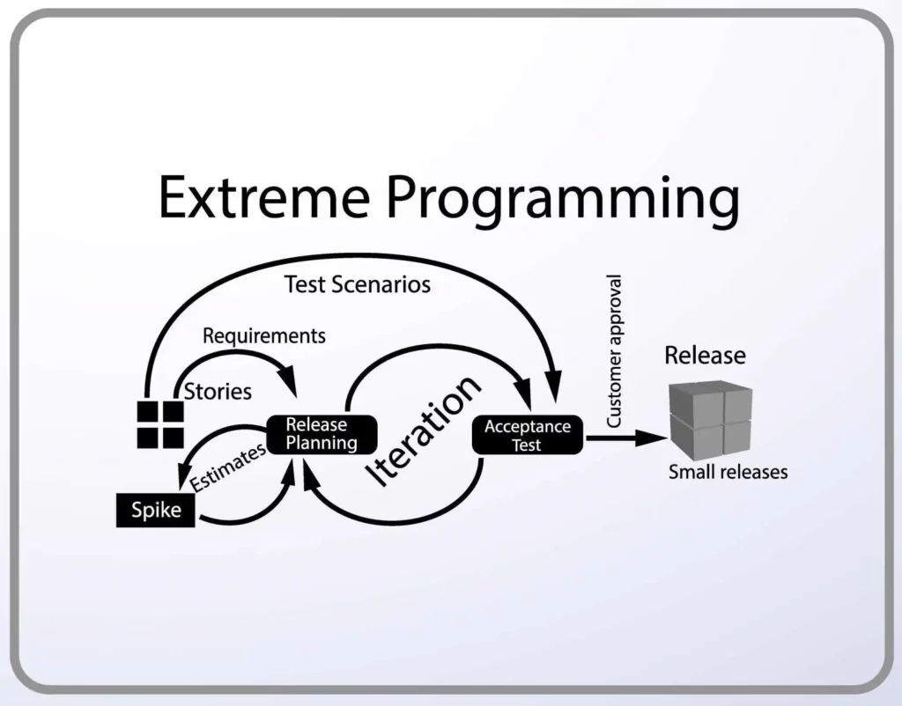

Extreme programming generally involves six phases:

1. Planning
2. Analysis
3. Design
4. Execution
5. Wrapping
6. Closure

**SCRUM VS KANBAN**

|  |  |
| --- | --- |
| **Scrum** | **Kanban** |
| It defines the role of each member of the Scrum team. | There is no role assigned to individuals. |
| It follows the iterative method. | It does not follow the iterative approach |
| To solve a problem, it breaks it into small tasks and then processes it further. | It does not break a problem into sub-problems. |
| It is a highly prescriptive approach. | It is not much prescriptive as compared to Scrum. |
| There is no visualization process to perform tasks. | There is a visualization process to perform tasks. |
| There are sprints that keep track of the progress of any project. | They use task cards to keep track of the progress of any project. |
| It is processed in successive sprints to complete a task. | It is used to optimize the task to complete a project. |
| It is not preferred when resources are limited. | It is preferred when tasks and resources are limited. |
| Scrum Master is the problem solver in case of a problem. | All the members are allowed to pick a problem and solve it. |
| The process does not get disturbed if a team member leaves in between a sprint. | The flow of work gets disturbed if a team member leaves in between. |
| The velocity of the sprint is used to measure the production. | The time taken to finish the project is the measure of production. |
| Estimation is crucial to Scrum because it places a strong emphasis on planning. | Estimation is not as important in Kanban as in scrum. |
| In scrum, cross-functional teams are important to deal with the issues that may occur during software development. | In Kanban, specialized teams are important. |
| Only one team owns a sprint backlog. | The sharing among multiple teams is possible with Kanban board. |
| The scrum methodology is centered on the backlog. | The Kanban methodology is centered on the process dashboard. |
| It is suitable for projects that have changing priorities. | It is suitable for projects that have stable priorities i.e. unlikely to change over time. |
| “Velocity” through sprints is a production measurement metric. | “Cycle time” is a production measurement metric. |
| One to four weeks make up a sprint cycle. | The delivery cycle is continuous. |